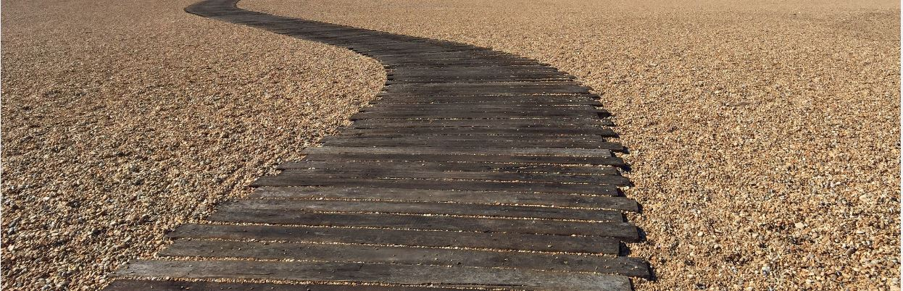
Jointon Mews
Jointon Road, Folkestone,
Kent CT20 2RF

Pricelist

Pebble – Plot 36 - 1423 ft² / 132.24m² £425,000
Three bedroom, semi-detached with 2 en-suites, plus 2 parking spaces.

Cobble – Plot 37 - 1425 ft² / 132.46m² SOLD
Three bedroom, semi-detached with 2 en-suites, plus 2 parking spaces.

Rock – Plot 38 - 2173 ft² / 201.88m² £595,000
Five bedroom detached, 2 en-suites, 2 bathrooms with single garage plus driveway.

Pebble – Plot 39 - 1423 ft² / 132.24m² SOLD
Three bedroom, semi-detached with 2 en-suites, plus 2 parking spaces.

Cobble – Plot 40 -1425 ft² / 132.46m² SOLD
Three bedroom, semi-detached with 2 en-suites, plus 2 parking spaces. .

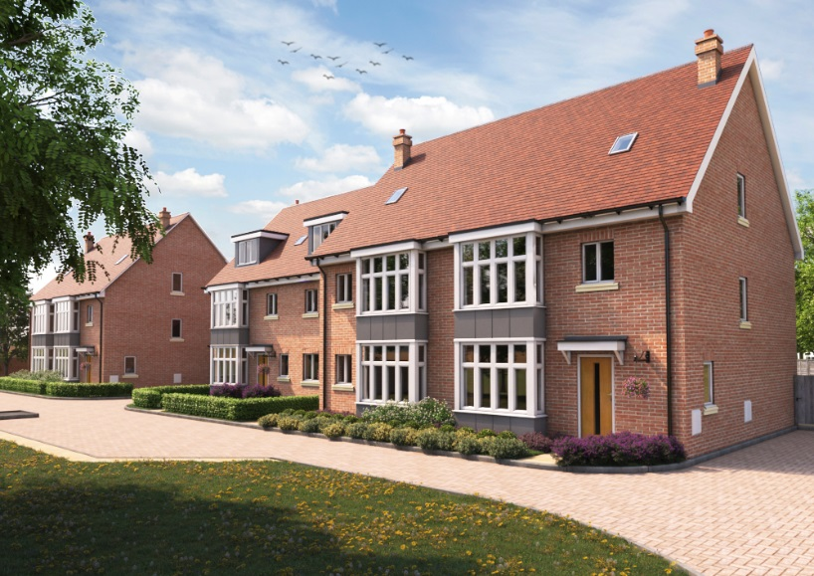

Murston Construction Ltd
mail@murstongroup.co.uk
www.murstongroup.co.uk
01233 664526

